Phase III: Software Design and Modeling
Personal Budget Tracker for Students

1. Software Architecture

1.1 System Architecture
The StudentBudget system follows a traditional server-side rendered web architecture using PHP as the backend language and MySQL as the database. Below is the step-by-step flow of how the system operates:

1. Student or Admin opens the application in a web browser and accesses the login page (Frontend).
2. The browser sends an HTTP POST request with email and password to login.php (Backend).
3. login.php calls database.php which uses PDO to query the MySQL database: SELECT user by email, then password_verify() checks the hashed password.
4. The backend checks the user's role (admin/student) and is_active status, creates a PHP session, and sends an HTTP redirect back to the browser.
5. If the user is a Student, they are redirected to dashboard.php which loads transaction data, budget data, and chart data from the database, renders HTML with Bootstrap, and sends it to the browser.
6. If the user is an Admin, they are redirected to admin/index.php which loads system-wide statistics (total users, all transactions, top spenders) and renders the admin dashboard.
7. When a Student adds a transaction, the form data is POSTed to transactions.php, which validates inputs, executes an INSERT query via PDO prepared statement, and on the next page load, checkBudgetAlerts() calculates spending percentage and creates a notification if >=80%.
8. When a Student creates a travel plan, travel.php queries country_costs table for average prices, calculates estimated expenses (flight, hotel, food, transport, activities, misc), and inserts them into travel_expenses table.
9. All admin actions (user management, settings changes, category edits) are logged to the admin_logs table with a timestamp, action description, and target reference.

1.2 Component Diagram (UML)
The following component diagram shows the main components of the StudentBudget system and how they interact. The system is divided into three layers:

Left side — Actors: Student and Admin interact with the system through their web browsers. Students access the student panel (dashboard, transactions, budget, travel, charity, routine). Admins access the admin panel (user management, system reports, settings).

Middle — Application Components: These are the core modules of the system:
Authentication: Handles user registration, login with bcrypt password verification, session management, and role-based redirects (admin vs student).
Transaction: Manages creation and deletion of income/expense records, supports filtering by type, month, and category.
Budget: Allows students to set a total monthly budget and per-category spending limits, calculates usage percentages, and provides daily spending recommendations.
Reports: Produces visual analytics using Chart.js: 6-month trend bar charts, category doughnut charts, daily spending line charts, yearly overviews, and top expense rankings.
Travel: Enables students to create trip plans with auto-estimated costs based on destination country data (flight, hotel, food, transport, activities), and tracks actual vs estimated expenses.
Charity: Records donations with organization, amount, date, notes, and recurring flag; displays 6-month donation trend charts.
Routine: Allows students to build a weekly activity schedule with per-activity cost estimates; calculates total weekly and projected monthly routine costs.
Categories: Provides default income/expense categories with icons and colors; allows students to create custom categories.
Notification: Automatically generates budget warning notifications when spending reaches 80% or exceeds 100% of the monthly budget; prevents duplicate alerts.
Admin Module: Full CRUD for student accounts (activate, deactivate, delete, reset password), system-wide financial reports, default category management, country cost data management, system settings, and activity logging.

Right side — Infrastructure: Security layer handles password hashing (bcrypt/Encryption) and role-based access control (Access Control). Persistence layer uses PDO with prepared statements for all database operations. Database Connector links the persistence layer to the MySQL Database which stores all persistent data across 12 tables.

Data Access: meaning each component reads/writes data from the database through the Persistence (PDO) layer.

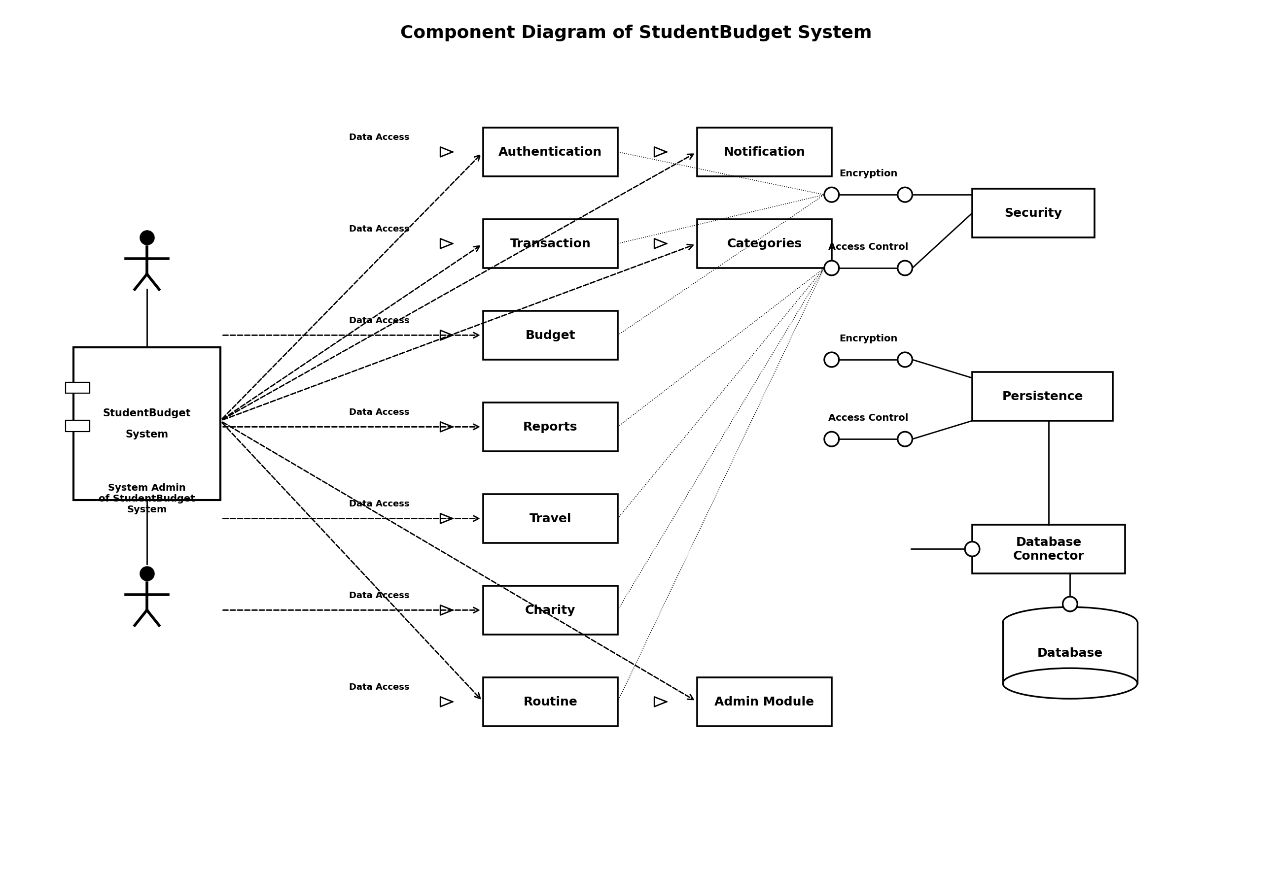

2. Detailed Design

2.1 Class Diagram
The class diagram below shows all 12 classes in the system, their attributes, methods, and relationships. The classes map directly to the MySQL database tables defined in sql/database.sql. Key relationships include: User has one-to-many relationships with Transaction, Donation, TravelPlan, Routine, Notification, and BudgetLimit. TravelPlan has a one-to-many relationship with TravelExpense. TravelPlan uses CountryCost data for cost estimation. AdminLog references User (admin) for action tracking. Transaction and BudgetLimit both reference Category. All classes are interconnected through these relationships.

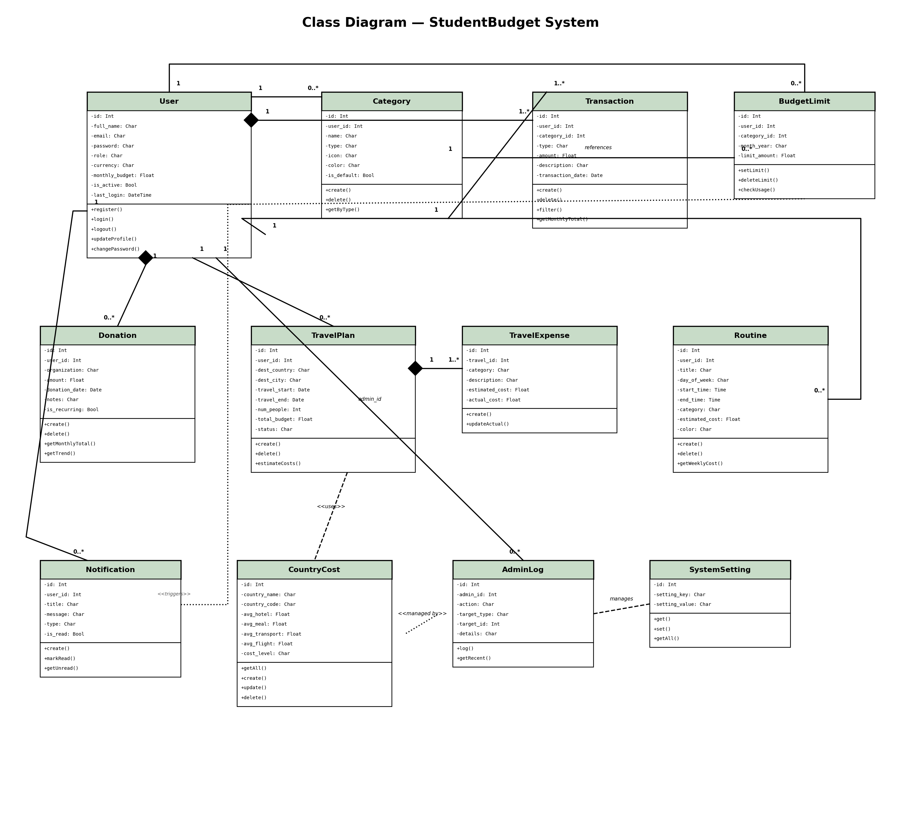

2.2 Sequence Diagrams
The following three sequence diagrams illustrate the step-by-step interactions between system components for the key processes implemented in the application.

2.2.1 User Login and Role-Based Redirect
This diagram shows how a user (student or admin) authenticates and gets redirected to the appropriate dashboard. The process involves: form submission to login.php, credential verification via PDO query and bcrypt password_verify(), session creation with role storage, last_login timestamp update, and role-based redirect (student to dashboard.php, admin to admin/index.php).

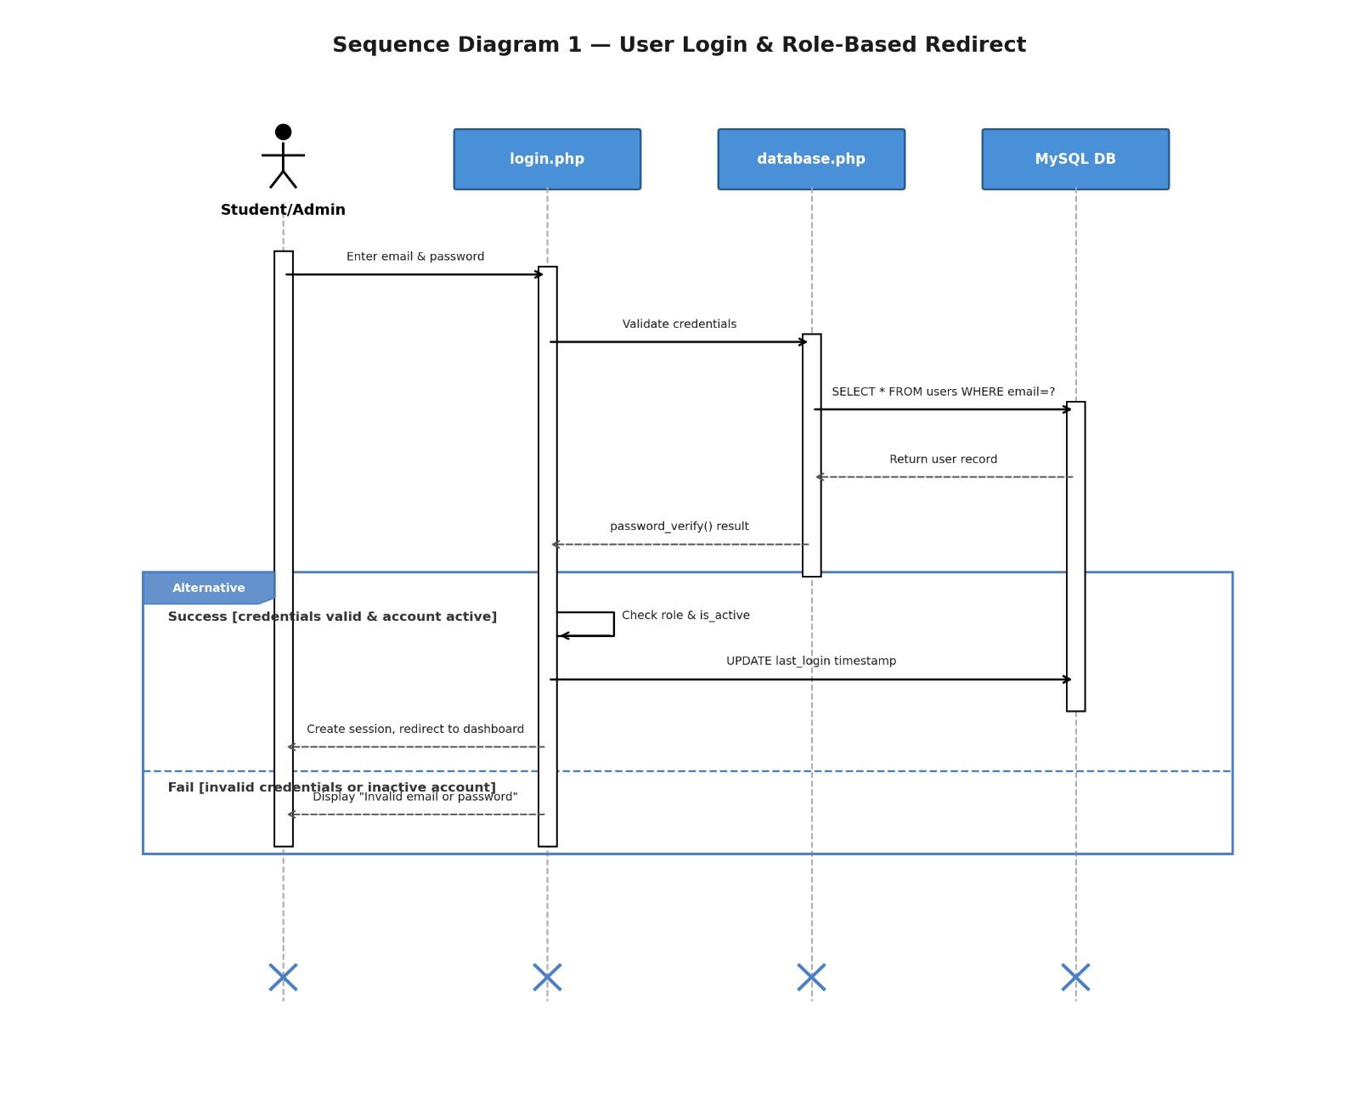

2.2.2 Add Transaction with Budget Alert Check
This diagram shows the flow when a student adds a new transaction. After the transaction is inserted into the database, the page reload triggers header.php which calls checkBudgetAlerts(). This function sums the monthly expenses, compares against the monthly budget, and creates a notification if spending reaches 80% or exceeds 100%.

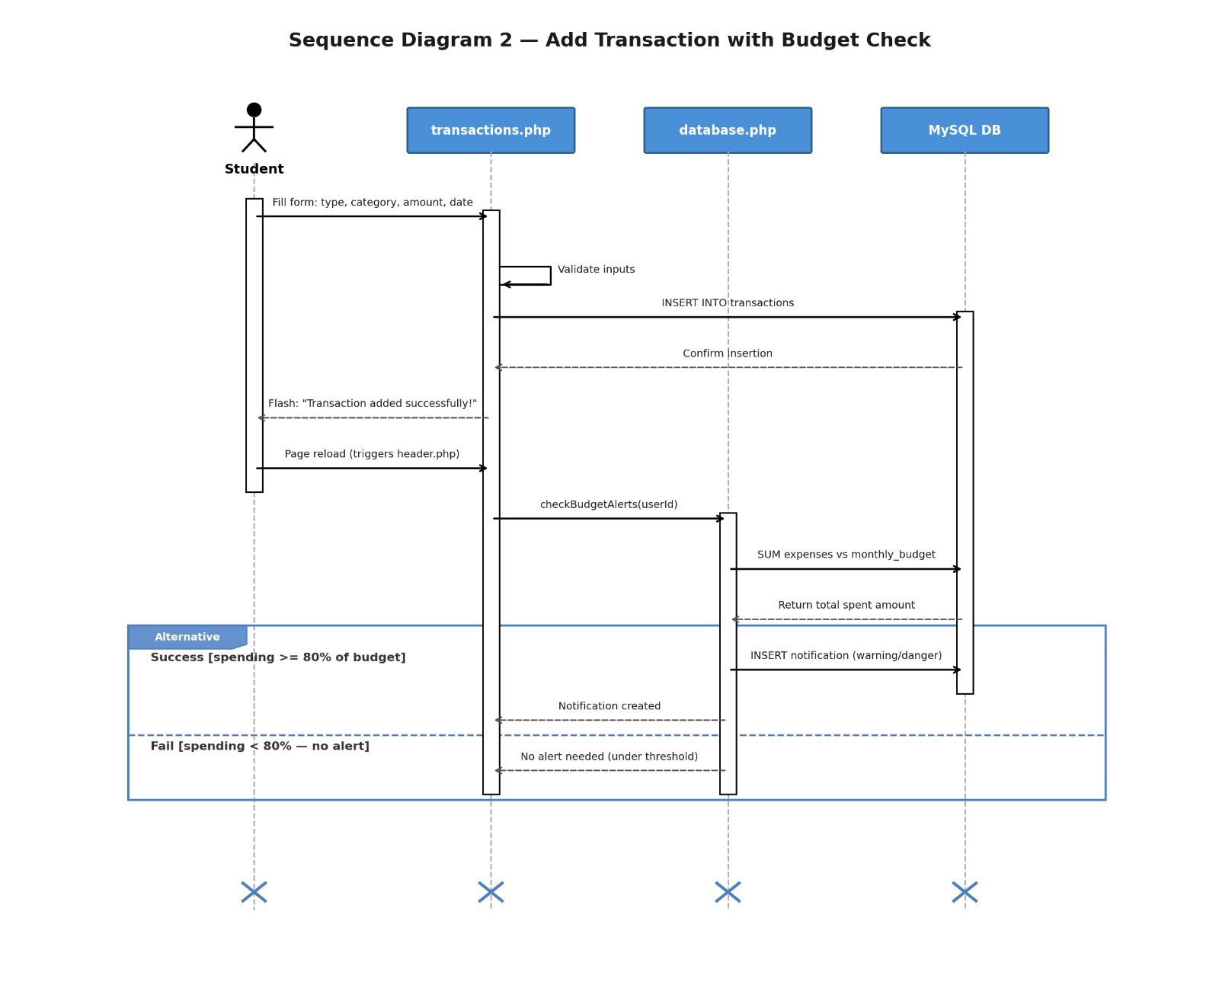

2.2.3 Create Travel Plan with Automatic Cost Estimation
This diagram shows how the system automatically estimates travel costs when a student creates a new trip plan. After inserting the travel plan, the system queries the country_costs table for average prices, calculates 6 expense categories (flight, accommodation, food, transport, activities, miscellaneous), inserts them into travel_expenses, and updates the total_budget field.
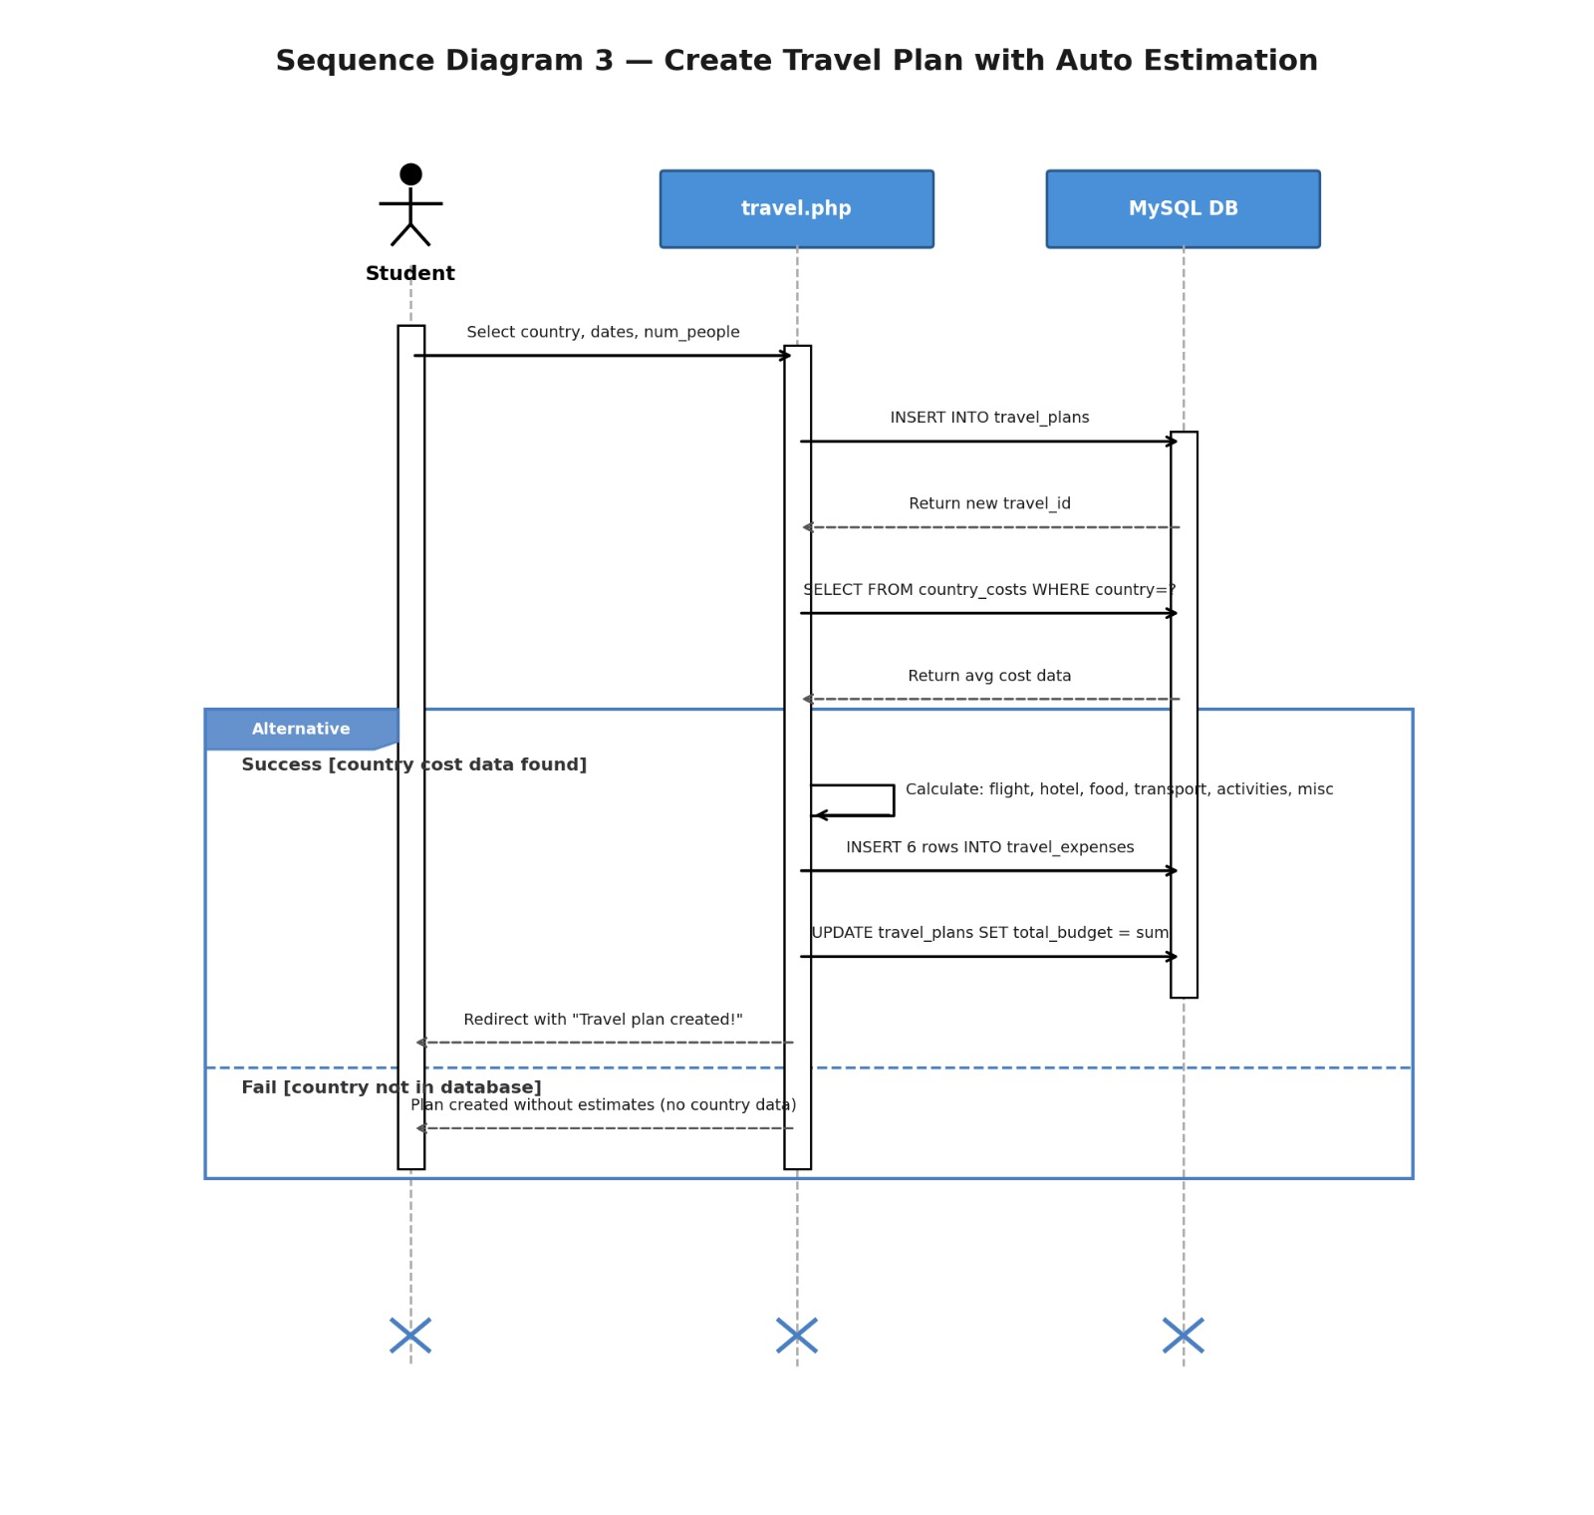

3. Modeling

3.1 Use Case Diagram
The use case diagram below shows how the two actors (Student and Admin) interact with the system. The Student has 10 use cases covering personal finance management, and the Admin has 8 use cases for system administration. Both actors share the Login/Logout use case. All use cases shown are fully implemented in the current version.

Student use cases: Register Account, Login/Logout, Add Transaction, View Dashboard, Set Monthly Budget, View Reports & Charts, Plan Travel Budget, Record Donation, Manage Routine, Manage Categories.
Admin use cases: Manage Users (activate/deactivate/delete/reset password), View All Transactions, System Reports, View All Donations, Manage Default Categories, Manage Country Costs, View Activity Log, System Settings.

<<include>> relationships: Register Account and Login both include Authentication. Add Transaction includes Check Budget Alert. Plan Travel Budget includes Estimate Travel Costs.
<<extend>> relationships: View Dashboard extends to View Reports & Charts (optional detailed view). Check Budget Alert extends to Create Notification (only when threshold reached). Manage Users extends to Reset Password. System Reports extends to Per-Student Breakdown.

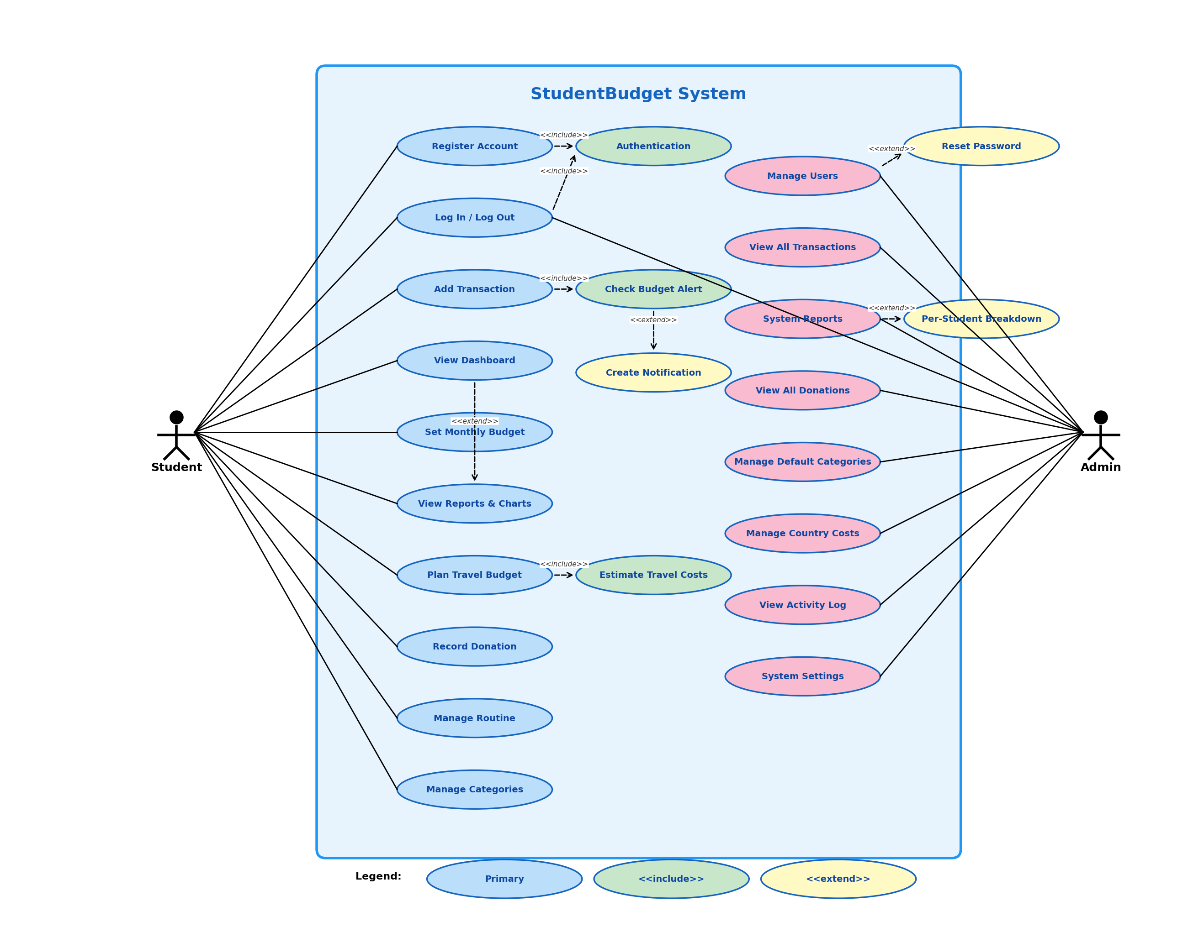

3.2 Activity Diagrams
The following activity diagrams describe the step-by-step flowcharts for two key processes in the system.

3.2.1 Add Transaction Activity
This flowchart shows the complete process when a student adds a transaction: opening the page, filling the form, validation, database insertion, flash message display, and the automatic budget alert check that runs on page reload.
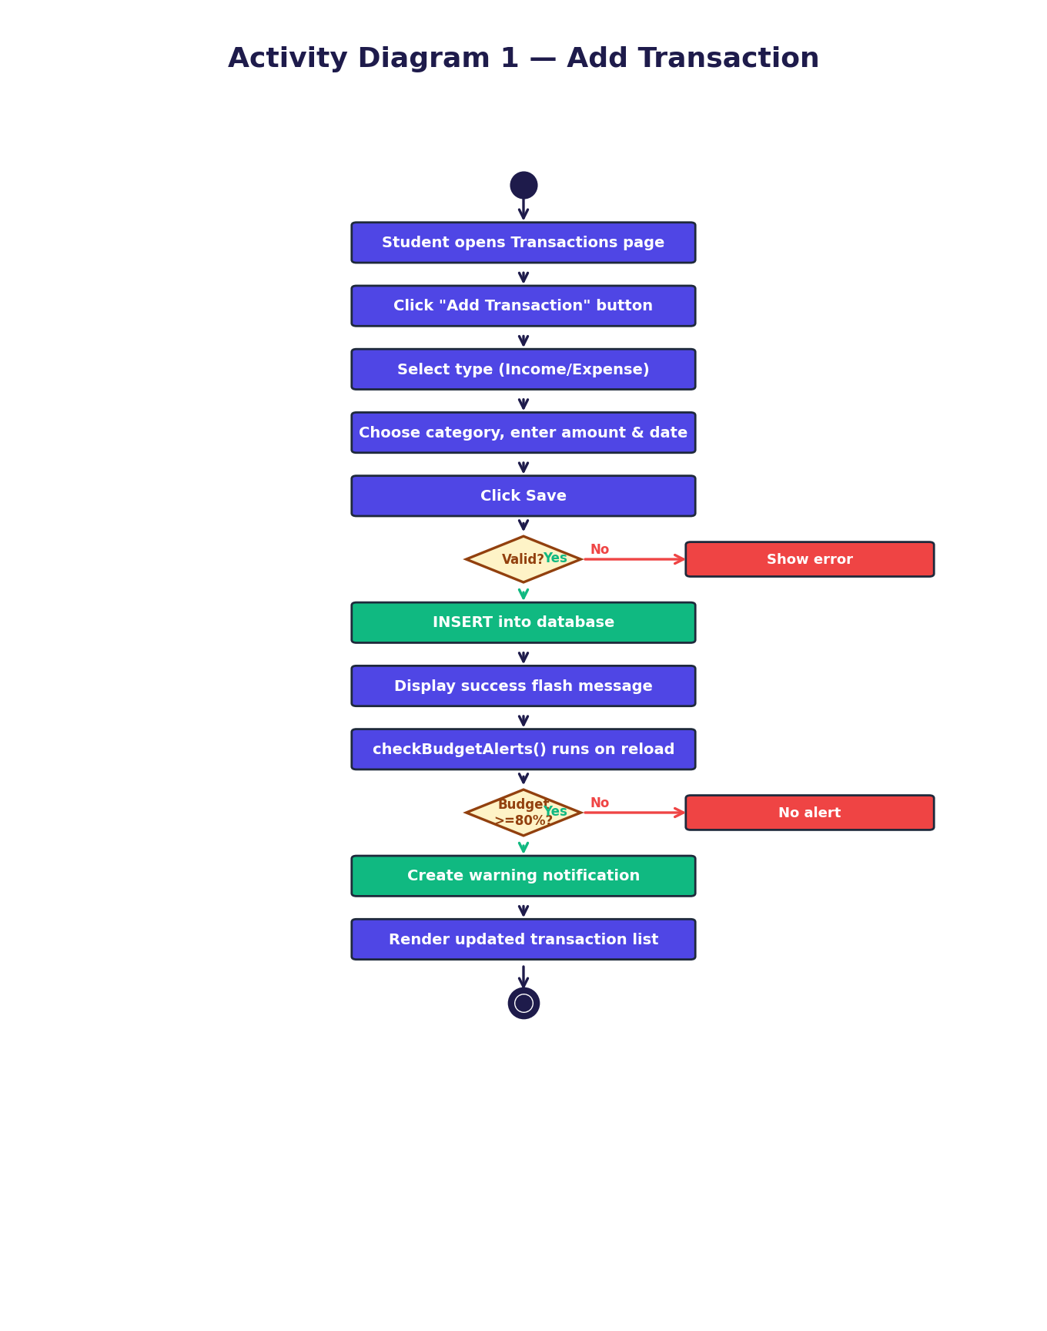

3.2.2 User Login Activity
This flowchart shows the login process with three decision points: credential validation, account active status check, and role-based routing. Invalid credentials show an error, deactivated accounts show a specific message, and successful logins redirect to the appropriate dashboard.
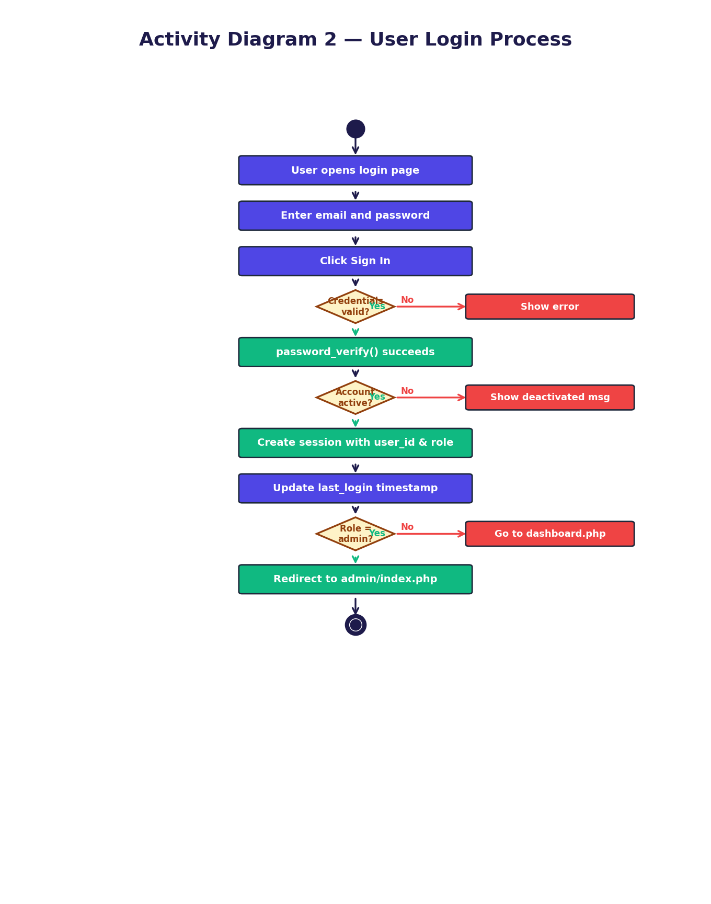

3.3 State Diagrams
The following state diagrams illustrate how key objects in the system transition between different states during their lifecycle.

3.3.1 User Account Lifecycle
A user account begins in the Registered state upon registration, transitions to Active upon first login, can be toggled between Active and Deactivated by an admin, and reaches the End state when the account is deleted (either by the student themselves or by an admin).
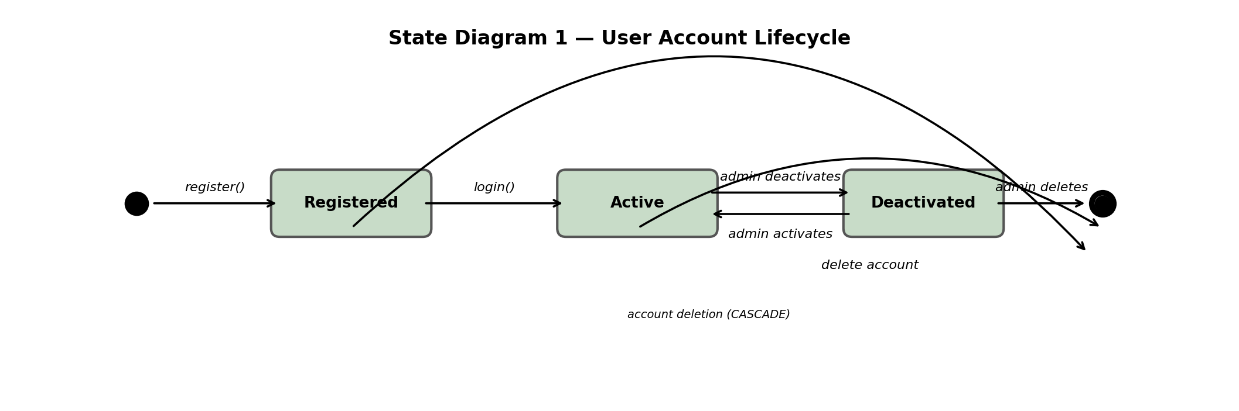

3.3.2 Travel Plan Lifecycle
A travel plan starts in the Planning state when created. It transitions to Active when the travel dates begin, then to Completed when the trip ends. A plan can be deleted from either the Planning or Completed state. All transitions terminate at a proper End state.
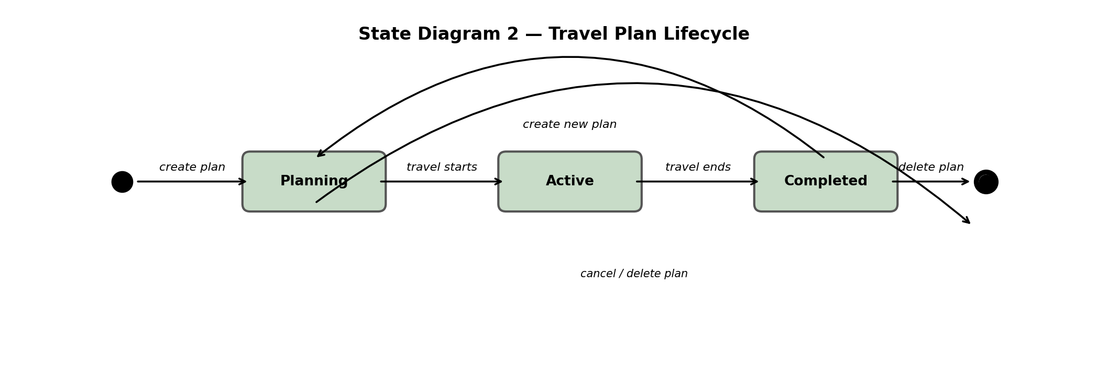

3.3.3 Notification Lifecycle
Notifications are Created (Unread) when the budget alert system detects spending at 80% or 100%. They transition to Read when the student clicks on them. Notifications are removed when the user account is deleted via CASCADE delete, reaching the End state.
